Oracle Virtual Directory (IDM Single Node) - Blueprint Information

# Overview

The purpose of this document is to describe the Oracle Virtual Directory blueprint (as part of the IDM Single Node blueprint) in detail. The goal of the blueprint is to allow for provisioning and configuration of a single node Oracle Virtual Directory (OVD) instance in an automated and repeatable fashion.

The following components and versions are installed as part of the OVD instance:

1. Weblogic Server 10.3.2
2. OVD of Oracle Identity Management 11g Release 1 (11.1.1.2.0)

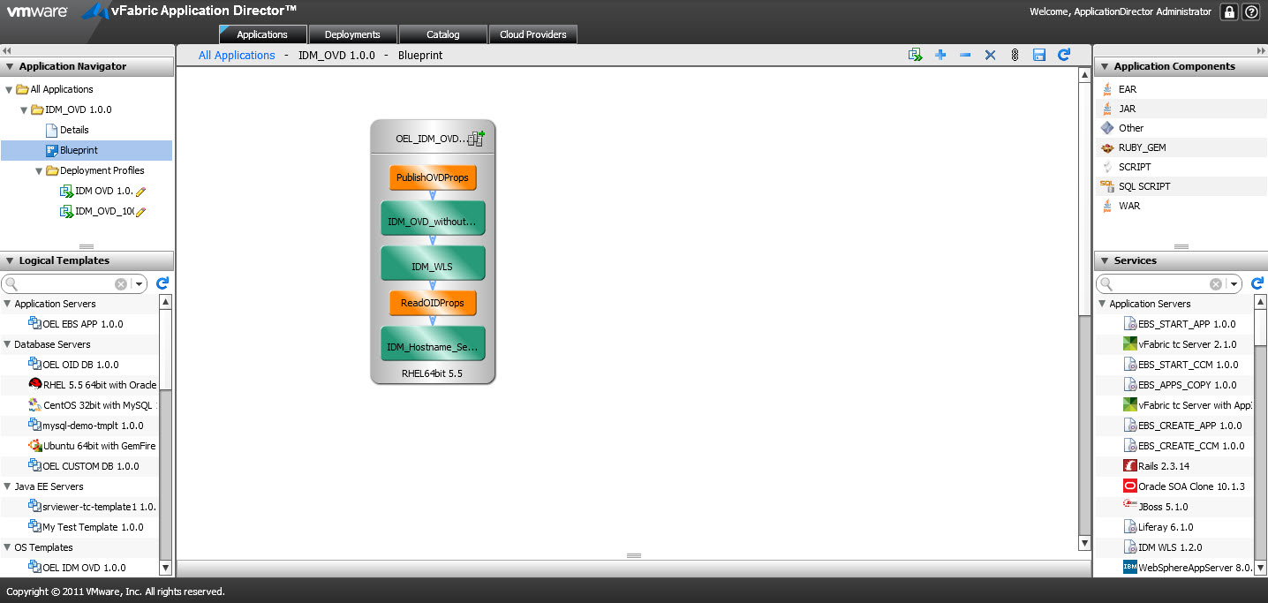

# High level BLUEPRINT Design

Conceptually, the blueprint design consists of the tasks described below. These tasks are listed in chronological order:

1. Setup Host Name
2. Retrieve Oracle Internet Directory (OID) Properties
3. Install Weblogic Server 10.3.2
4. Install OVD of Oracle Identity Management 11g Release 1 (11.1.1.2.0)
5. Publish OVD Properties

## Files

You will need access to create the following file repository that contains the necessary installers and configuration files needed. We will refer to this repository as the “Mount Point Location” in this document.

$MOUNTPOINTLOCATION/IDM:

wls/ Installation and configuration directory of Weblogic Server 10.3.2

wls1032_generic.jar Installation package of Weblogic Server 10.3.2

ovd/ Installation and configuration directory of OVD

Disk1/ Installation package (Disk1) of OVD

Disk2/ Installation package (Disk2) of OVD

Disk3/ Installation package (Disk3) of OVD

Templates/ OVD installation and configuration templates

im_install_config.rsp OVD silent installation response file Template

oraInst.loc OVD installation location file

localStoreOUs.ldif ldif file to create local store OUs

adapters.os_xml Configuration file to create OVD adapters

mod_vmwperson.ldif ldif file to customize “vmwperson” object class

perforce/Templates/ Perforce templates used for inter-blueprint communications

ovd.properties OVD properties file

You will also need below files to configure the scripts and services within this blueprint. Please refer to the following sections for details and their corresponding script/service.

IDM_Hostname_Setup_INSTALL.txt

ReadOIDProps_INSTALL.txt

IDM_WLS_INSTALL.txt

IDM_OVD_without_WLS_INSTALL.txt

IDM_OVD_without_WLS_CONFIGURE.txt

## Setup Host Name

The “Setup Host Name” task sets the hostname for the machine that’s provisioned. It’s defined as a blueprint service.

Properties:

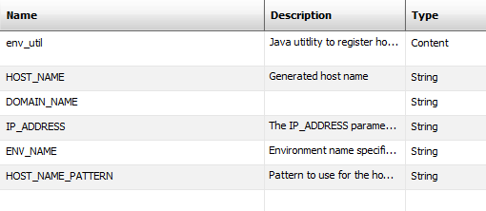

Actions:

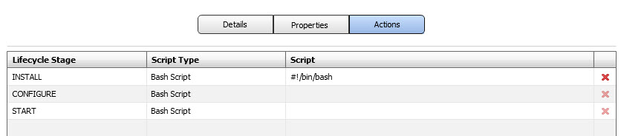

Install Script:

Please refer to file **IDM_Hostname_Setup_INSTALL.txt** to copy the script as the INSTALL Bash Script.

## Retrieve Oracle Internet Directory (OID) Properties

The “Retrieve Oracle Internet Directory (OID) Properties” task retrieves the OID information that OVD needs to connect to from Perforce. It’s defined as a blueprint script.

Properties:

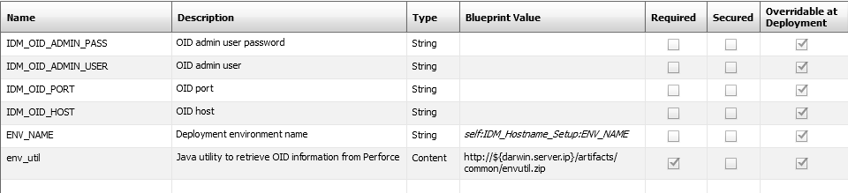

Actions:



Install Script:

Please refer to file **ReadOIDProps_INSTALL.txt** to copy the script as the INSTALL Bash Script.

## Install Weblogic Server 10.3.2

The “Install Weblogic Server 10.3.2” task installs a Weblogic Server as the administration console of OVD. It’s defined as a blueprint service.

Properties:

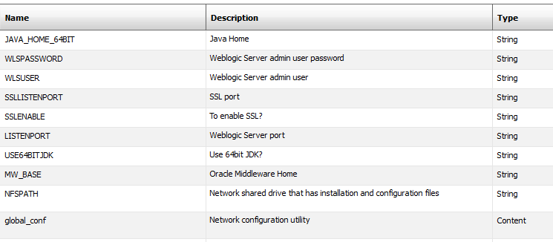

Actions:



Install Script:

Please refer to file **IDM_WLS_INSTALL.txt** to copy the script as the INSTALL Bash Script.

## Install OVD of Oracle Identity Management 11g Release 1 (11.1.1.2.0)

The “Install OVD of Oracle Identity Management 11g Release 1 (11.1.1.2.0)” task installs an OVD server instance. It’s defined as a blueprint service.

Properties:

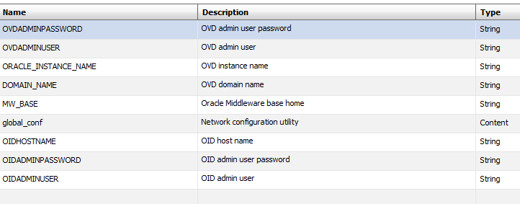

Actions:

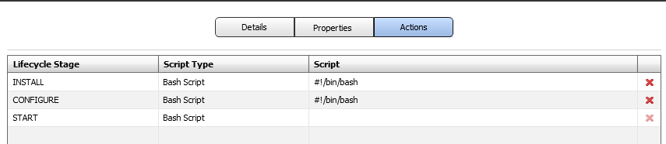

Install Script:

Please refer to file **IDM_OVD_without_WLS_INSTALL.txt** to copy the script as the INSTALL Bash Script.

Please refer to file **IDM_OVD_without_WLS_CONFIGURE.txt** to copy the script as the CONFIGURE Bash Script.

## Publish OVD Properties

The “Publish OVD Properties” task publishes the OVD information to Perforce. It’s defined as a blueprint script.

Properties:

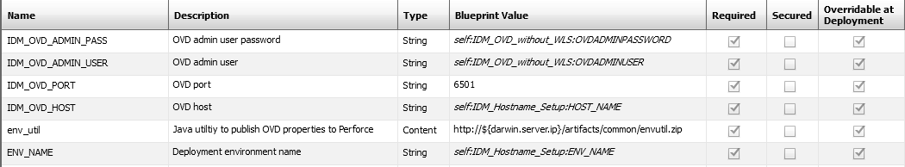

Actions:



Install Script:

Please refer to file **PublishOVDProps_INSTALL.txt** to copy the script as the INSTALL Bash Script.